PM Procedure for Hitachi Airis II MRI System

Requirements:
PM tool kit
PM form
This procedure

You represent OVMS. Remember to represent well—professional, courteous. The good seeds you plant in customer relations will almost always come back in multiplied ways.

Enter site making small talk with MRI tec. Ask if any system issues or coil problems. Listen carefully and ask clarifying questions to ensure you understand giving them confidence that you hear them and will address any issue they raise. Remember to record appropriate information in your report.

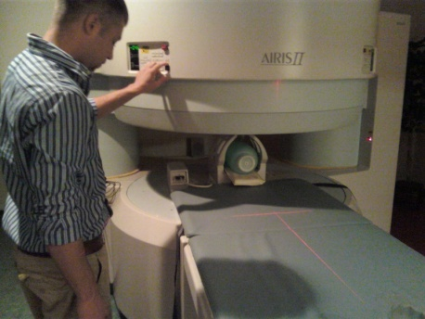
Head Coil
Visual check, tighten screws
Phantom 3
FOV 260
SNR spec. 115
AVG 138
Use defaults 1 ROI centered in phantom for SNR
Check and record transmitter forward and reverse power (peak needle deflection) during head coil SNR scan.

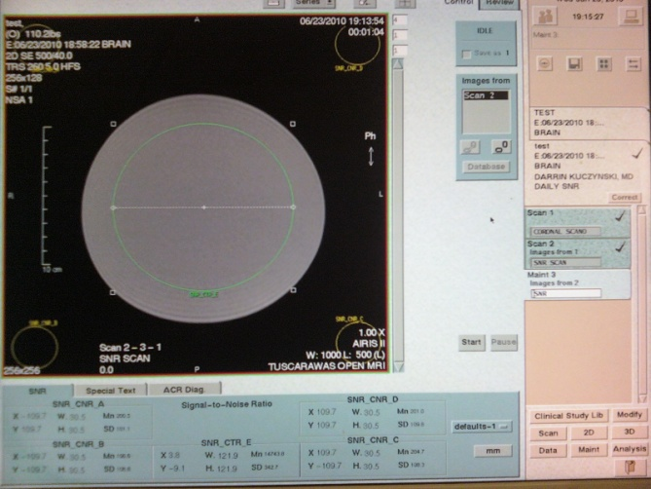

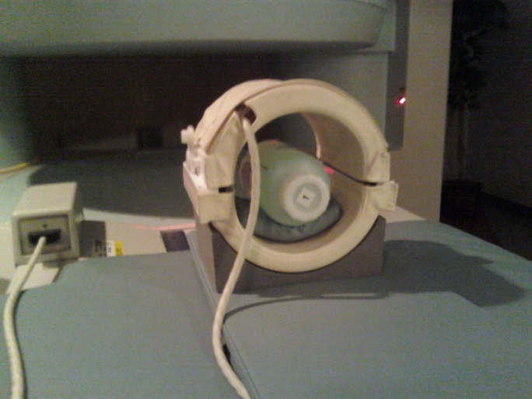

Knee Coil
Visual check, tighten screws
Phantom 1
FOV 180
SNR spec. 125
AVG 158
Use defaults 2 ROI centered in phantom for SNR

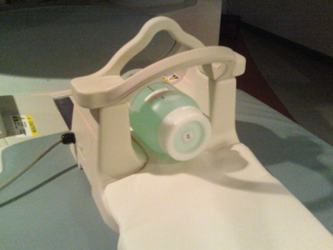

C-Spine Coil
Visual check, tighten screws
Phantom 2
FOV 260
SNR spec. 158
AVG 184
Cover entire phantom image with ROI for SNR

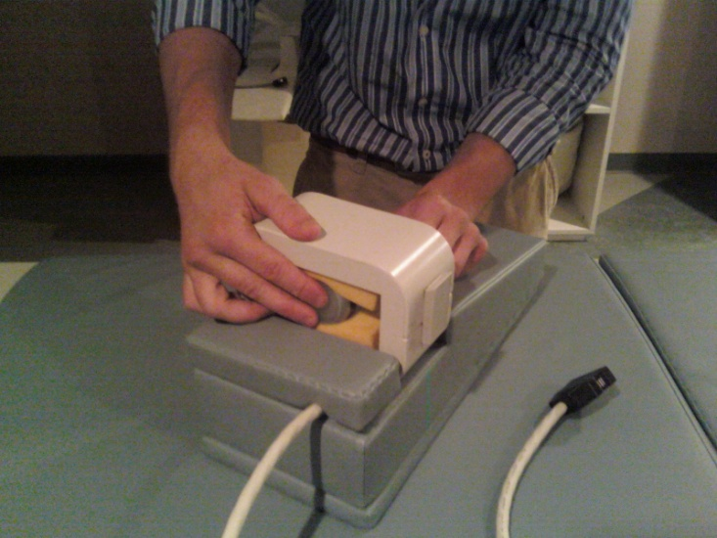

Wrist Coil
Visual check, tighten screws
Phantom 6
FOV 120
SNR spec. 113
AVG 152
Use defaults 2 ROI centered in phantom for SNR

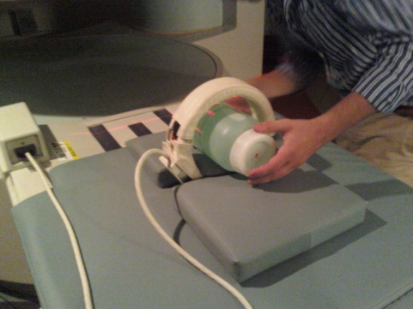

Joint/Neck Coil
Visual check, tighten screws
Phantom 2
FOV 260
SNR spec. 118
AVG 146
Use defaults 2 ROI centered in phantom for SNR

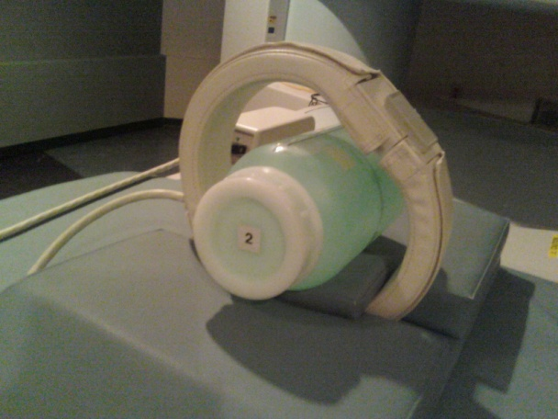
Large Extremity Coil
Visual check, tighten screws
Phantom 2
FOV 260
SNR spec. 117
AVG 150
Use defaults 2 ROI centered in phantom for SNR

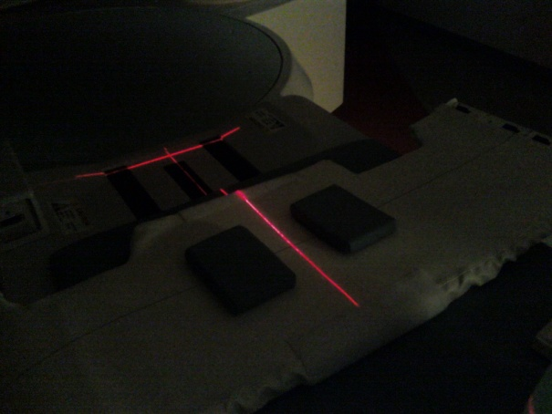
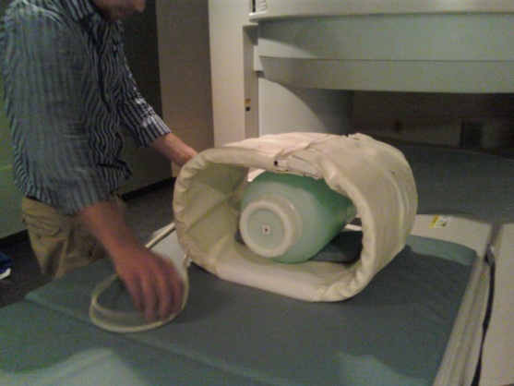

Med Flex Coil
Visual check, tighten screws
Phantom 4
FOV 320
SNR spec. 70
AVG 84
Use defaults 1 ROI centered in phantom for SNR

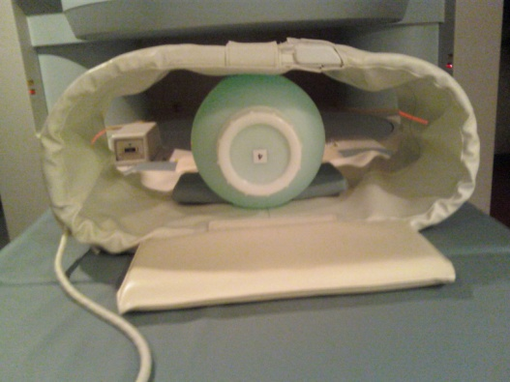

Large Flex Coil
Visual check, tighten screws
Phantom 4
FOV 320
SNR spec. 57
AVG 72
Use defaults 1 ROI centered in phantom for SNR

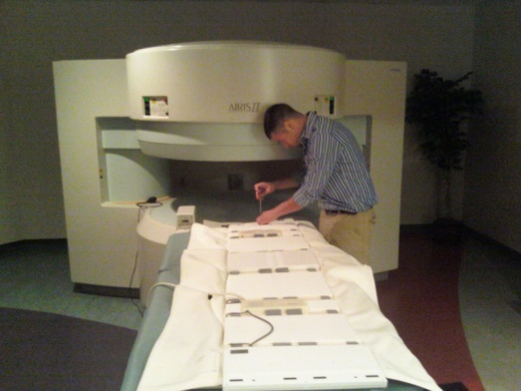

Xlarge Flex Coil
Visual check, tighten screws
Phantom 4
FOV 320
SNR spec. 34
AVG 52
Use defaults 1 ROI centered in phantom for SNR

QD and MAC Shoulder Coil
Visual check, tighten screws
Center on Landmark and then advance the table to -65
Sagittal SNR scan
Phantom 3
FOV 260
SNR spec. QD 110, MAC 125
AVG 146
Use defaults 1 ROI centered in phantom for SNR

Shaped Shoulder Coil
Visual check, tighten screws
Phantom 2
FOV 260
SNR spec. 98
AVG 129
Use defaults 2 ROI centered in phantom for SNR

CTL Coil
Follow procedure in CTL coil manual.

